Additional file 3 – Supplementary tables and figures
Table of Contents
Supplementary Table 1: Baseline characteristics of each male cohort 1
Supplementary Figure 1: Boxplots of the 95% percentile range of risk for individuals across the 1000 models (male cohort) 2
Supplementary Figure 2: Boxplots of 95% percentile ranges, stratified by C statistic (female cohort) 3
Supplementary Figure 3: Boxplots of 95% percentile ranges, stratified by C statistic (male cohort) 4
Supplementary Figure 4: Boxplots of the 95% percentile ranges, stratified by calibration (female cohort) 5
Supplementary Figure 5: Boxplots of the 95% percentile ranges, stratified by calibration (male cohort) 6

Supplementary Table 1: Baseline characteristics of each male cohort
 |  | Development  (n=1 790 582) | Validation  (n = 100 000) | 2016  (n = 387 557)
Outcome | CVD events | 101360 | 5691 | NA
 | Follow up (years) | 12291619 | 685616 | NA
Age |  | 41.85 (14.57) | 41.84 (14.53) | 46.86 (13.64)
Systolic blood pressure |  | 130.04 (16.48) | 129.89 (16.48) | 130.22 (13.93)
Body mass index |  | 26.12 (4.53) | 26.13 (4.55) | 27.43 (5.07)
Cholesterol/high density lipoprotein ratio |  | 4.48 (1.4) | 4.48 (1.38) | 4.17 (1.25)
Smoking status | Never | 46.63% | 46.55% | 37.17%
 | Ex | 17.37% | 17.52% | 30.07%
 | Current | 35.99% | 35.93% | 32.76%
Townsend | 1 (least deprived) | 21.65% | 21.56% | 24.18%
 | 2 | 21.50% | 21.46% | 21.74%
 | 3 | 20.77% | 20.89% | 21.61%
 | 4 | 20.77% | 20.94% | 19.03%
 | 5 (most deprived) | 15.30% | 15.15% | 13.45%
Treated hypertension |  | 4.51% | 4.45% | 7.16%
Family history of CVD |  | 11.02% | 11.00% | 14.85%
Type 2 diabetes |  | 1.42% | 1.43% | 1.46%

Supplementary Figure 1: Boxplots of the 95% percentile range of risk for individuals across the 1000 models (male cohort)
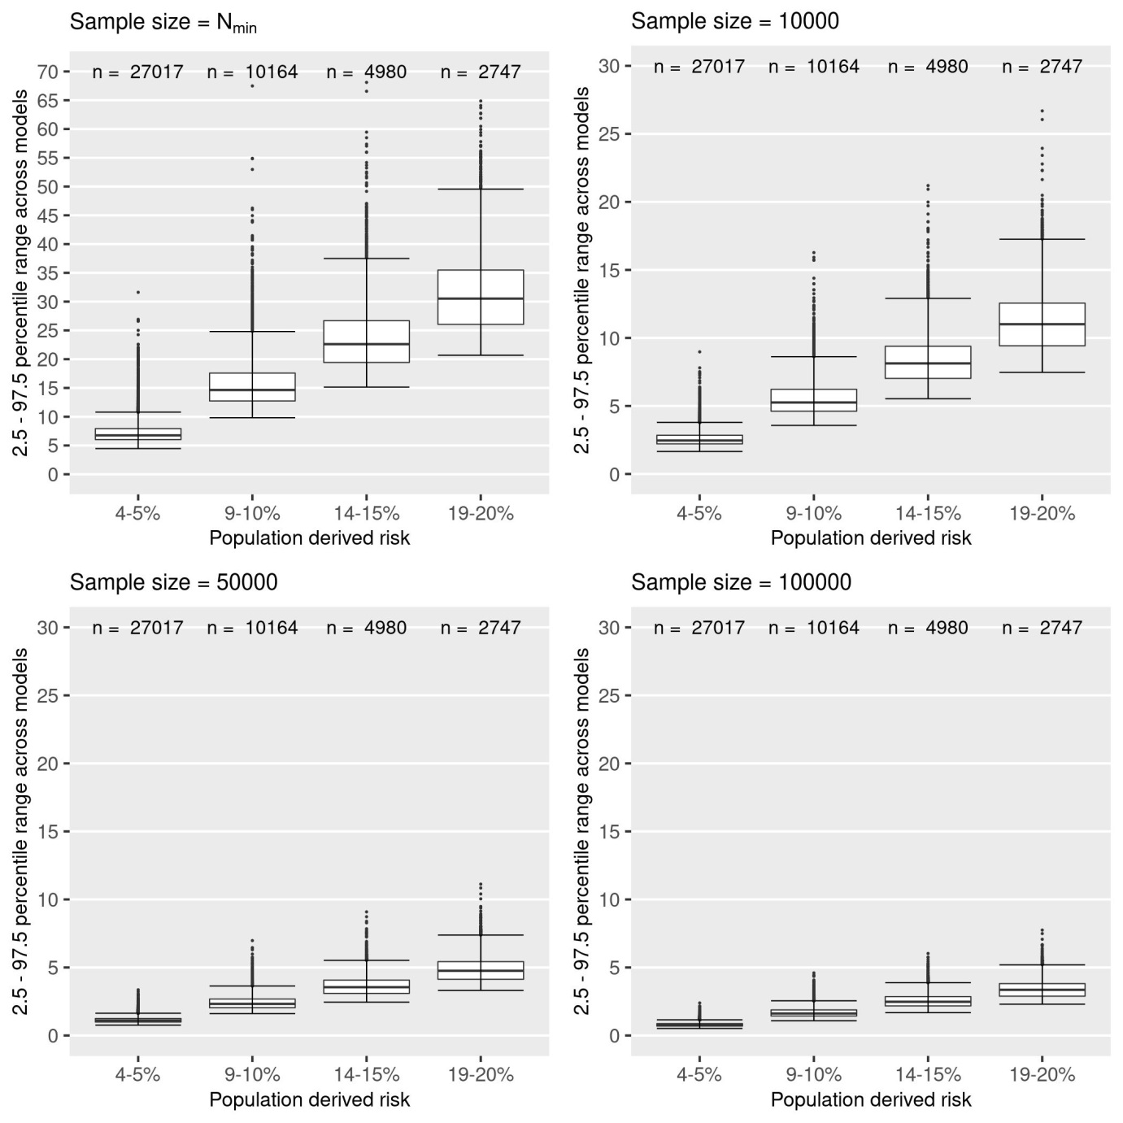

Supplementary Figure 2: Boxplots of 95% percentile ranges, stratified by C statistic (female cohort)
Sample size = N_{min}
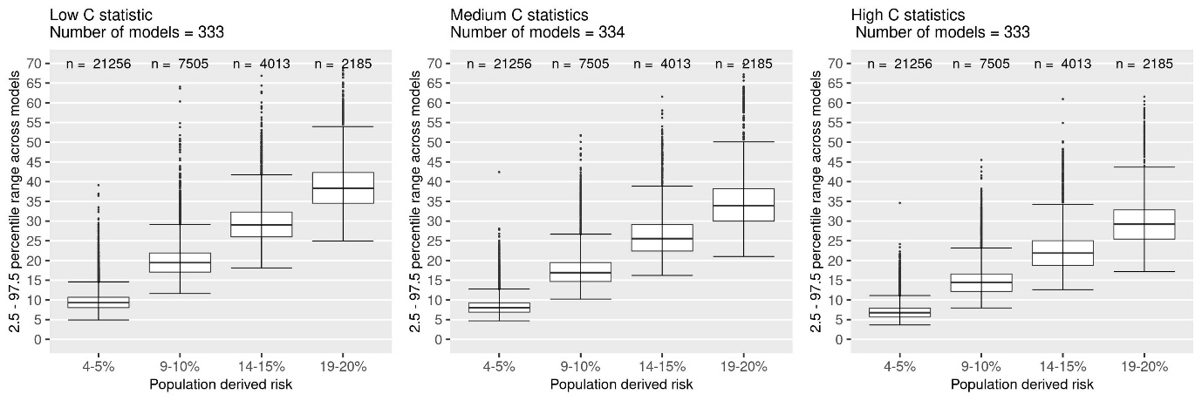
Sample size = 50 000
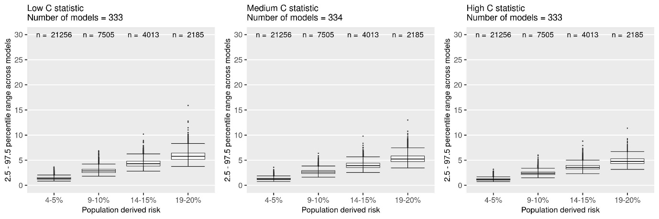
Sample size = 100 000
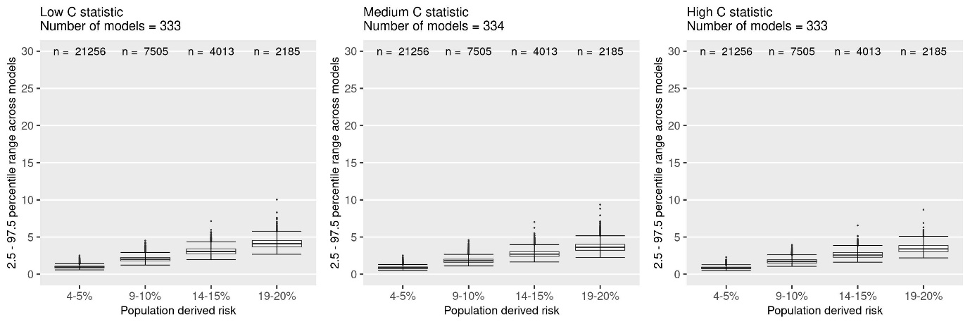

Supplementary Figure 3: Boxplots of 95% percentile ranges, stratified by C statistic (male cohort)
Sample size = N_{min}
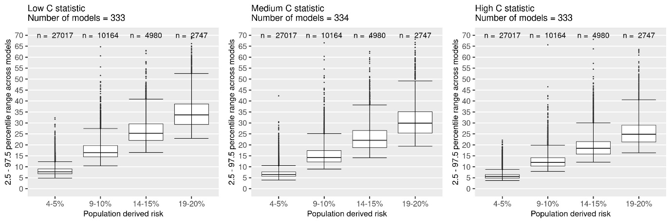
Sample size = 10 000
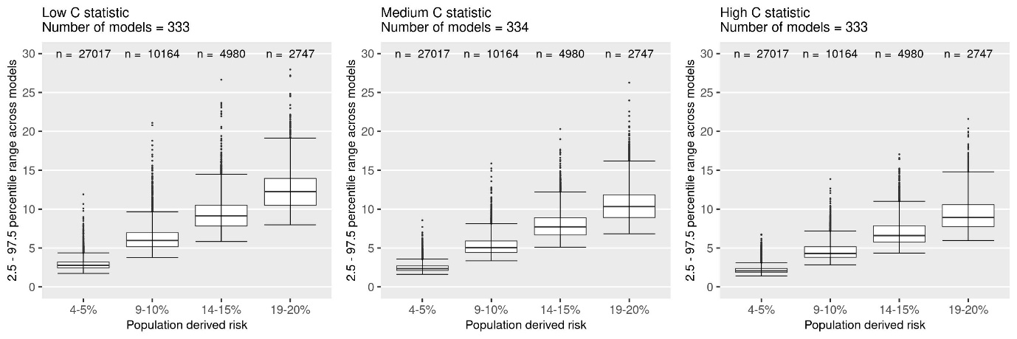
Sample size = 50 000
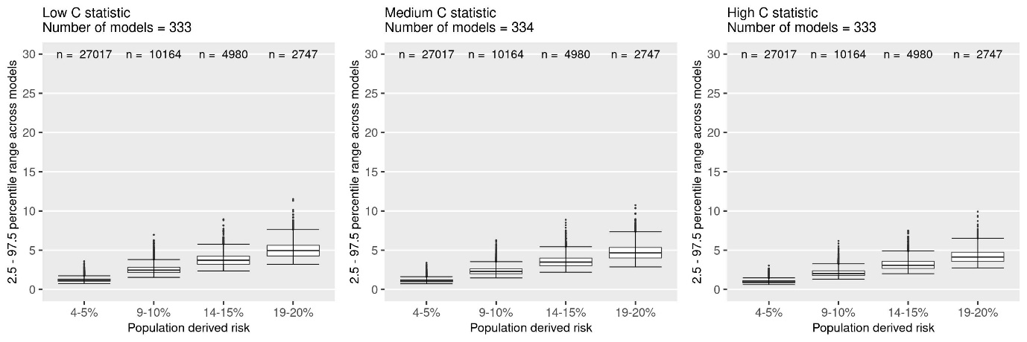
Sample size = 100 000
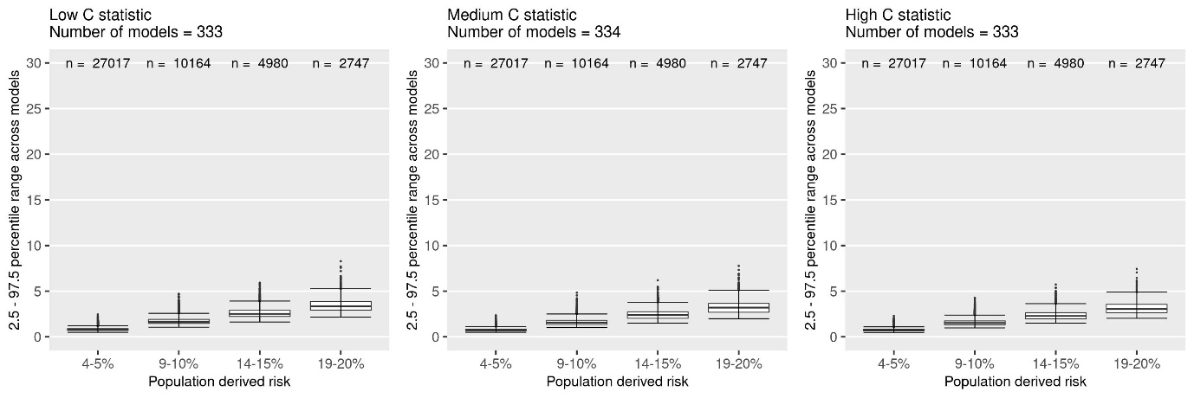

Supplementary Figure 4: Boxplots of the 95% percentile ranges, stratified by calibration (female cohort)
Sample size = N_{min}
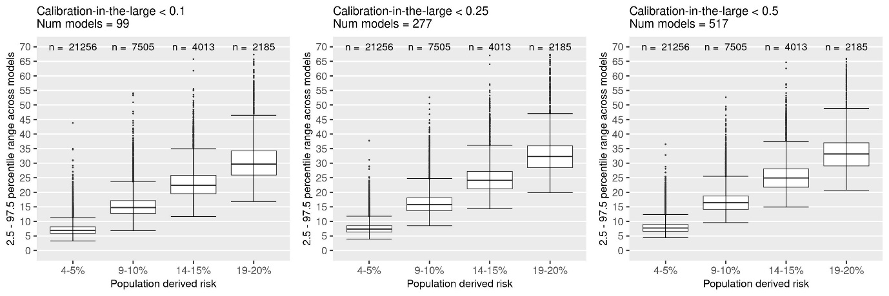
Female Figure 3 Sample size = 50 000
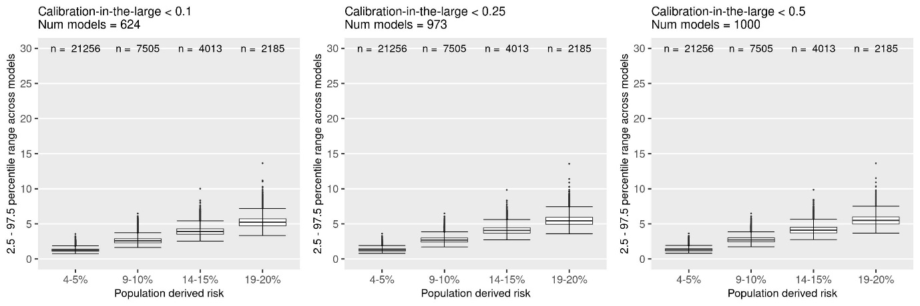
Female Figure 3 Sample size = 100 000
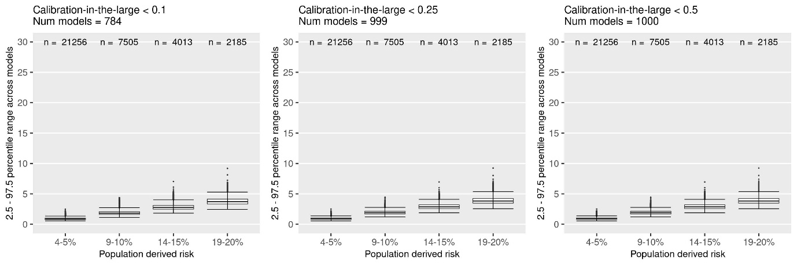

Supplementary Figure 5: Boxplots of the 95% percentile ranges, stratified by calibration (male cohort)
Male Figure 3 Sample size = N_{min}
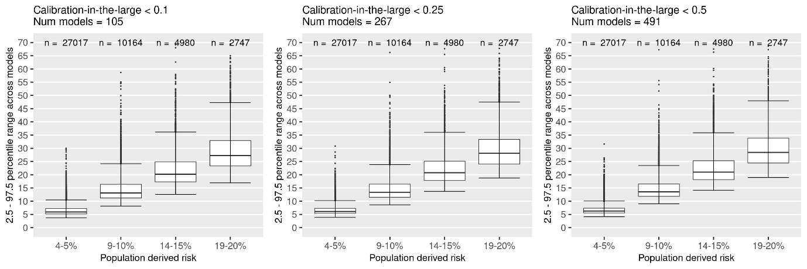
Male Figure 3 Sample size = 10 000
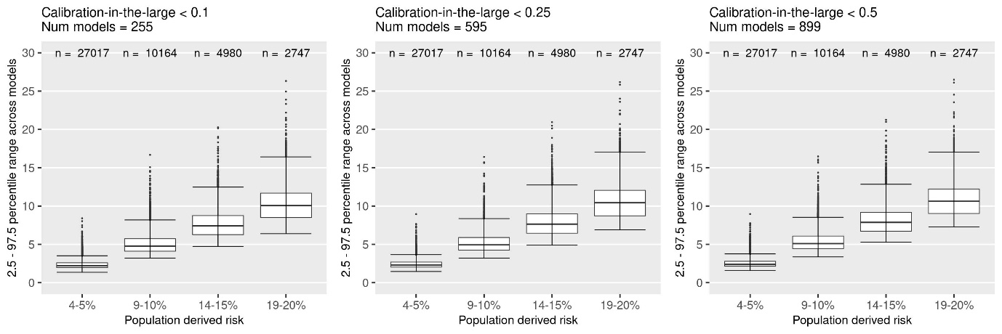
Male Figure 3 Sample size = 50 000
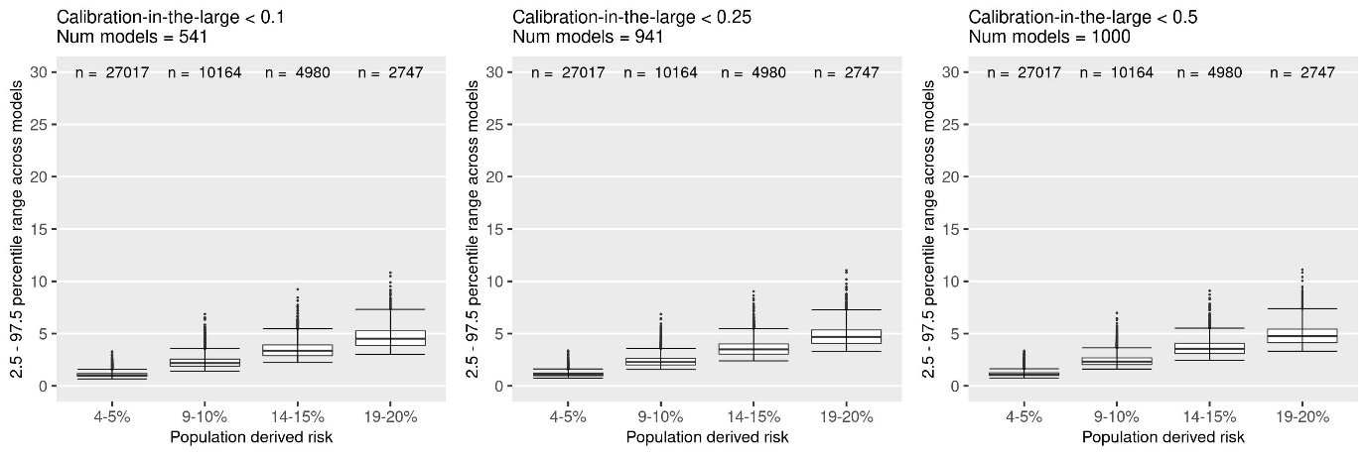
Male Figure 3 Sample size = 100 000
